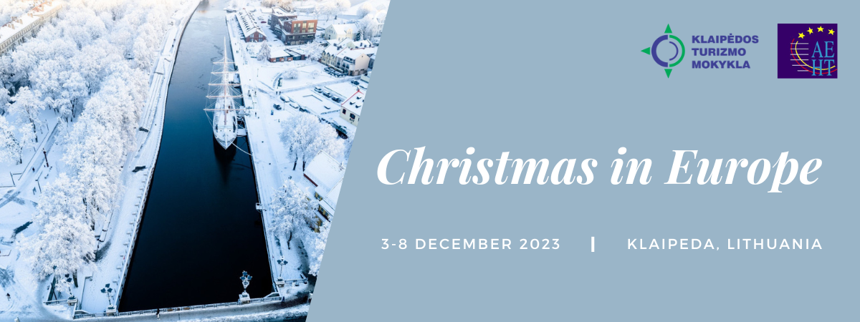

CULTURAL PERFORMANCE

We expect that your performance will take 8-10 minutes. Please, fill in the table below and send it until 15th November 2023 to: projects@ktm.lt

Name of performance | Short description | Necessary equipment  for the show | Any additional info

