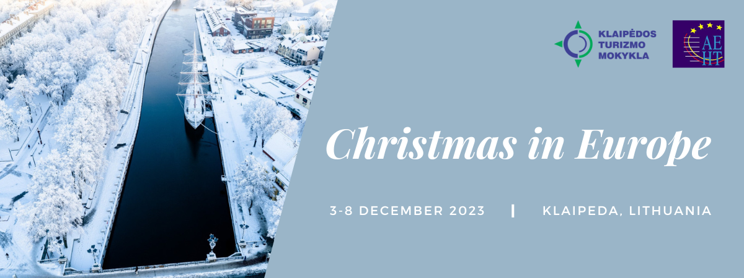

Location:

Klaipėda Tourism School, Taikos pr. 69, 94112 Klaipeda, Lithuania

Dormitory address: same as school (For taxis only: Baltijos pr. 22 Klaipeda)

Contact persons:

Audrius Kurlavicius, director +370 676 42006

Jelena Korch, project coordinator +370 677 10026

Email for all communication: projects@ktm.lt

Prices (per participant):
- Students/teachers in the dormitory: € 226,50
- Students/teachers in hotel: € 214,00 + hotel costs (€ 36 single room, € 45 double room)
APPLICATION FORM
Please send us the information until the 1st of October.
Country | School | Ms/Mr. | Name, surname | Student/ teacher

